IMPLEMENTATION OF SYMMETRIC ALGORITHM MODIFICATION SYSTEM TO RESIST POWER BASED SIDE CHANNEL ATTACKS

Software Requirement Specification

Project ID: 17 – 044
K.P.A.P Pathirana

BSc. Special Honors in Information Technology Specializing in Cyber Security
IMPLEMENTATION OF SYMMETRIC ALGORITHM MODIFICATION SYSTEM TO RESIST POWER BASED SIDE CHANNEL ATTACKS

Project ID: 17 – 044

Submitted on: _______________

IT14120930 – K.P.A.P Pathirana signature: ……………....

Supervisor

……………………………………
Mr.kavinga Yapa Abeywardena

DECLARATION

I declare that this is my own work and this project proposal does not incorporate without acknowledgement any material previously submitted for a Degree or Diploma in any other University or institute of higher learning and to the best of my knowledge and belief it does not contain any material previously published or written by another person except where the acknowledgement is made in the text.

K.P.A.P Pathirana ………………………………
Signature

Table of Contents
1 Introduction 6
1.1 Purpose 6
1.2 Scope 6
1.3 Definitions, Acronyms, and Abbreviations 6
1.4 Overview 7
2 Overall Description 7
2.1 Product Perspective 8
2.1.1 System Interface 8
2.1.2 User Interface 9
2.1.3 Hardware interfaces 9
2.1.4 Software interfaces 9
2.1.5 Communication interfaces 10
2.1.6 Memory constraints 10
2.1.7 Operations 10
2.1.8 Site adaptation requirements 10
2.2 Product Functions 11
2.3 User Characteristics 11
2.4 Constraints 11
2.5 Assumptions and dependencies 11
2.6 Apportioning of requirements 11
3 Specific Requirements 12
3.1 External interface requirements 12
3.1.1 User interfaces 12
3.1.2 Hardware interfaces 12
3.1.3 Software interfaces 13
3.1.4 Communication Interfaces 13
3.2 Architectural Design 13
3.2.1 High level Architectural Design 13
3.2.2 Hardware and software requirements with justification 13
3.2.3 Risk Mitigation Plan with alternative solution identification 14
3.2.4 Cost Benefit Analysis for the proposed solution 14
3.3 Performance Requirements 14
3.4 Design Constraints 14
3.5 Software System Attributes 14
3.5.1 Reliability 14
3.5.2 Availability 14
3.5.3 Security 14
3.5.4 Maintainability 15

1 Introduction
  - Purpose
This software requirement specification (SRS) document will provide all the functional and non – functional requirements for the phase Device implementation for extracting power consumption measurements of the IMPLEMENTATION OF SYMMETRIC ALGORITHM MODIFICATION SYSTEM TO RESIST POWER BASED SIDE CHANNEL ATTACKS system. All Parts of this phase are planned and to meet the requirement of getting an accurate power consumption reading for analysis purposes.
  - Scope
This document will cover the details of the phase Device implementation for extracting power consumption measurements of this project. The objective of this phase is to implement a device that allows to gather power consumption information from a target device that runs an encryption algorithm while providing a data set on power consumption for the next phase.
And all to achieve above phase of the project, it needs to identify proper facilities that are needed like proper power measurement method, necessary hardware parts require for the device, language use for the algorithms that are used to gather data. By combining above parts and function this phase will give an output of a data set that I ready to be analyzed by the next phase.
1.3 Definitions, Acronyms, and Abbreviations
SRS | Software Requirement Specification
PUF | Physical Unclonable Function
SCA | Side Channel Attacks
IC | Integrated Circuit
FIA | Fault Injection Attacks
EM | Electromagnetic
ML | Machine Learning

1.4 Overview
Side Channel Attacks (SCA) are type of attack the use to break encryption. This type of attacks are one of the most trending attack type used by hacker in the present. SCA is not a typical type of attack method which uses mathematics and logics. SCA use the information like heat, sound, power consumption, electromagnetic etc… that are emit from the device and use these information to analyze an encryption algorithm to get a key.
Out of many methods of side channel attacks this project is based on power consumption information. The reason is power consumption is one of the most commonly use method by attackers and it is very cost effective compared to other methods. Also power consumption based SCA’s can be easily mounted with less effort and this is considered as one of the most reliable side channel information source.
The main objective of this product is to secure the encryption algorithm against power based SCA by modifying the algorithm on a code level to prevent recognizing power consumption patterns. For this we recognize the possible vulnerabilities that will cause patterns and implement countermeasures by modifying the algorithm that are necessary to prevent a SCA.
- Overall Descriptions
Most of the time encryption algorithms are only protected from mathematical and logic based attacks and they are not secured against side channel attacks. This system will provide the necessary solution for the problem with power based side channel attacks. There are three main processes that need to be followed to strengthen an encryption algorithm against side channel attacks.
Device implementation for extracting power consumption measurements is the first process. In here the collection of power consumption information will be take place. The information collection will be done through a device. This device will have the capability of collecting power consumption information and feed that information to a PC as digital data. Then analyze them by reducing noise to get an accurate reading and provide an output as a dataset.
As the second step data classification, analysis and module training using machine learning. The gathered data from the step one will be introduce here and these data will be again processed by formatting, fixing wrong data and sampling methods to get a better organized meaningful data set. Then processed data set will be introduced to a machine learning techniques (ML) that trained to recognize vulnerabilities in the cryptographic algorithm and suggesting the necessary countermeasures.
In the final step, Automate Code embedding mechanism using machine learning for above recognized vulnerabilities, the suggested countermeasure will be implemented. All modification will be done in a code level without creating an impact to the output of the cryptographic algorithm. Machine learning techniques will be used to modify algorithm and this task will be done automatically. Both supervised/unsupervised ML techniques will be used here. After these three steps the final output of the system will be an algorithm that is secured against power based SCA.
  - Product perspective
There are other products in the market which are related to power based side channel attacks like SASEBO (Side channel Attack Standard Evaluation Board), CHIP WHISPERER and SAKURA-G. All of these devices are capable of performing a side channel attack by identifying patterns from the target devices and can derive a key or couple of partial keys. These devices have a very advanced design and complex design and they are not solely based on side channel attacks and can perform other kinds of attacks like Fault Injection Attacks (FIA), Physical Unclonable Function (PUF) and dynamic reconfigurations etc… and these devices cost around $300 – $400.
The main difference between our system and the system that mentioned above is, though these system in the market currently can implement a side channel attack they are not capable of providing a method prevent side channel attacks by finding an algorithms vulnerabilities and fixing them. And another difference is that our device is the design is minimalistic and simple with specific functionalities that is only relating to power consumption analysis which enables us to reduce the cost of the device. Any person with basic computer literacy can mount the device and run the necessary programs to modify the algorithm to secure it from power based SCA since all the tasks in the system are automated.

2.1.1 System interfaces
Since all the necessary functionalities are logical there will be no any interfaces.

2.1.2 User interfaces
Basic sketch of the user interface.
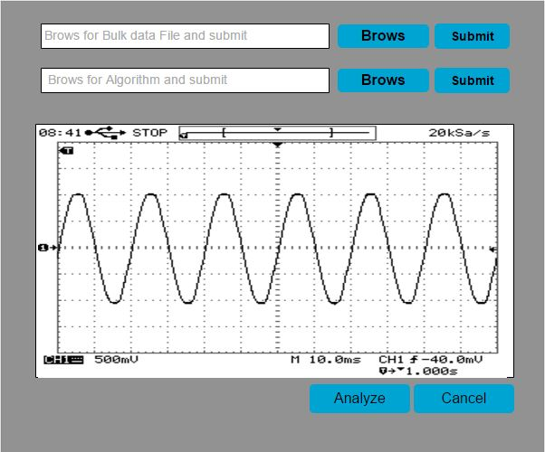

2.1.3 Hardware interfaces
A target device like an IC or a microprocessor is required to execute cryptographic algorithm. The device that is implementing will be gathering data from the target device and a PC will required to proceed with analyzing, finding vulnerabilities and implementing solutions.

2.1.4 Software interfaces
To develop algorithms, NetBeans will be used.
For databases MySql will be used.

2.1.5 Communication interfaces
For communication of power consumption reading between device and the PC a USB connection will be used.

2.1.6 Memory constraints
The device does not have separate memory since readings are done real-time and a PC with 1024mb RAM, 1024mb HDD space will be needed as a minimum requirement.

2.1.7 Operations
For this system there three component:
- Device implementation for extracting power consumption measurements.
- Data classification, analysis and module training using machine learning.
- Automate Code embedding mechanism using machine learning.
This SRS is mainly focused on device implementation part which enables user to gather power consumption information. The information that needs to collected will gather from a target device e.g. IC, microprocessor. For this the target device needs to be connected to the reading device. The cryptographic algorithm will be executed in the microprocessor and by connection of it to the device necessary measurement can be taken. The gathered information will be transferred to a computer as digital data through a USB connection and to store recorded data 1024mb HDD space will be required.
The transferred data will be analyzed to get accurate information by removing unnecessary data like noise. Process it as a proper data set for further analyzing purposes.

2.1.8 Site adaptation requirements
To run the device and the necessary application require a PC running Windows OD (XP or higher version) with a minimum memory 1024mb RAM and a storage of 20GB HDD (including the OS) for installing applications data storage. Using a 1024mb RAM is recommended since analyzing tasks uses a lot of memory.

2.2 Product functions
In the device implementation for information gathering user can gather power consumption information of any cryptographic algorithm by executing the algorithm in an IC or a microprocessor which is connected to our measurement reading device. The measurement taken by the device will send to the PC. In the PC it will be given a graphical representation (a graph) which will give the user the benefit of better identifying the patterns. Also the values from the power consumption will be prepared as a data set.
The user should introduce the collected information to an algorithm which is in the PC for refining purposes. When prepare ring the data all raw data taken in from the device should be filtered to get the most accurate information. Some of the reading may have unwanted values which will cause from properties like noise which will affect the vulnerability find process. After that collecting all the necessary filtered values the data set will be prepared.
2.3 User characteristics
Most of the time, since the system is a security related product it will be used by a person with a sound knowledge security e.g. network admin, pen tester etc… but with the simplicity and user friendliness it will allow a novice to use the system without any complications.
2.4 Constraints
The management of the company/organization must decide which encryption algorithm is best for the task and set up with the system for testing side channel vulnerabilities.

2.5 Assumptions and dependencies
The Future versions of this system will be have more features and it will not be limit to power consumption and will be adding other types of side channel attacks e.g. electromagnetic.
The current applications are all based on windows OS and in the future version the applications for Linux and MAC will be released.

2.6 Apportioning of requirements
The primary requirements that are mentioned in section one and two should be followed as in the way they are stated when mounting the devices for information gathering and analysis to achieve proposed solution that describe in this document.

3 Specific requirements ⁽²⁾ (for Embedded System Oriented Projects - DD)
3.1 External interface requirements

3.1.1 User interfaces
Basic sketch of the user interface, the user has given the choice to choose the data bulk and the algorithm that is going to be tested according to his preference through the interface.

3.1.2 Hardware interfaces
Since the project is based on Side Channel Attacks (SCA) to gather side channel information (power consumption) hardware device will be used. And to analyzed data provide solutions to identified vulnerabilities a PC (with Windows OS) will be required.

3.1.3 Software interfaces
To implement algorithms and specified functions for analyzing data, java language will be used with NetBeans.
To implement database that is necessary for storing collected side channel information MySql will be used.

3.1.4 Communication interfaces
To collect data from the measuring device it should be connected to the PC and UBS interfaces will be used to make that communication line.

3.2 Architectural Design <For Embedded System related Projects >

3.2.1 High level Architectural Design
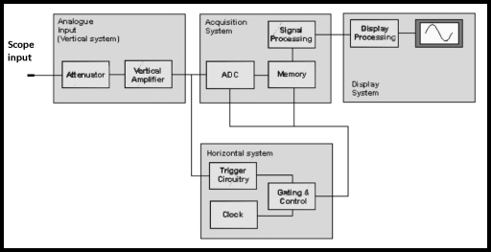

3.2.2 Hardware and software requirements with justification
Parts that are needed for the device capacitors, transistors, regulators, pin headers, power connectors etc… will be purchase from trusted vendors in order to get high quality product as an output and get correct results.
NetBeans will be used for coding purposes because the application is free and it will reduce the cost of production.

3.2.3 Risk Mitigation Plan with alternative solution identification
The parts that will be used in the device will be high quality and it will avoid the situation where defective parts get adding to the device and causing accidents.

3.2.4 Cost Benefit Analysis for the proposed solution
Since the device is simple and it doesn’t required any advance features the required parts also doesn’t cost much. The cost can be around $40 for the whole device. And we always try to rely on open source software which is free like NetBeans and MySql to reduce the cost.

3.3 Performance requirements
The device should run smoothly without any problems such as stuck in the middle of getting a reading from a target device.

3.4 Design constraints
Applications related with the device are password protected so that no person without the authorization cannot access to analyze algorithms or to get information on analyzed algorithms.

3.5 Software system attributes
3.5.1 Reliability
The device should not be stuck or crash while collecting side channel information or give out hardware problems. Even if it does the system should be able to recover from a crash using a recovery mechanism or a simple restart.

3.5.2 Availability
The device always be able to get power consumption readings anytime and anywhere the user needs. Should be able to interact with any PC with Windows OS any time and should have capability to deal with any cryptographic algorithm.

3.5.3 Security
The main objective of the product is to increase the security of cryptographic algorithms. So when an algorithm is modified to resist side channel attacks. It should not be able to identify any patterns that will help to break the encryption. And this can be tested by running the algorithm through device again to check if there are any power patterns.

3.5.4 Maintainability
Willing to provide any support regarding the device and application if there are any problems arises and providing updates for the system while fixing the bugs in the device.
Adding new features for the device like giving the capability to take electromagnetic (EM) reading for analyzing purposes.

